**TASK 2:**

1. 1. Insert at least 10 sample records into each of the following tables. • Customers • Accounts • Transactions

O/P:

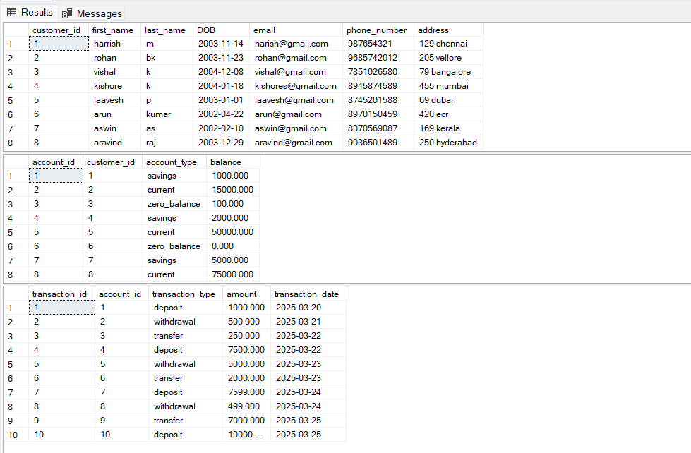

1. Write SQL queries for the following tasks:
2. Write a SQL query to retrieve the name, account type and email of all customers.

O/P

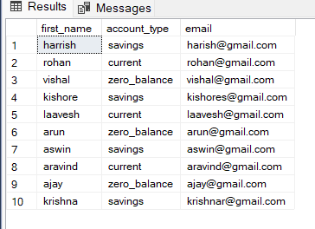

1. Write a SQL query to list all transaction corresponding customer.

o/p

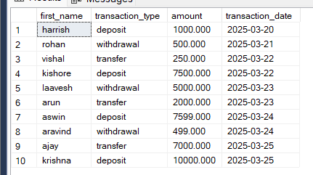

1. Write a SQL query to increase the balance of a specific account by a certain amount.

o/p

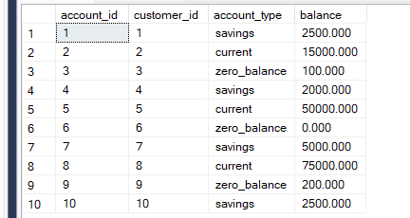

1. Write a SQL query to Combine first and last names of customers as a full_name

o/p

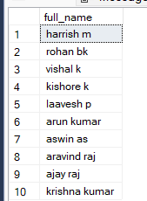

1. Write a SQL query to remove accounts with a balance of zero where the account type is savings.

o/p

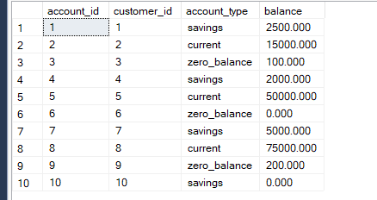

Here account_id has been deleted since it met the condition

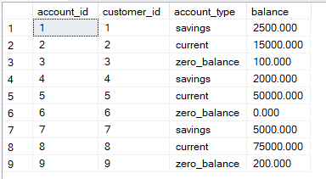

1. Write a SQL query to Find customers living in a specific city.

o/p



1. Write a SQL query to Get the account balance for a specific account.

o/p



1. Write a SQL query to List all current accounts with a balance greater than $1,000.

o/p

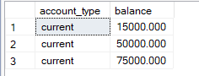

1. Write a SQL query to Retrieve all transactions for a specific account.

o/p

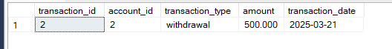

1. Write a SQL query to Calculate the interest accrued on savings accounts based on a given interest rate.

o/p

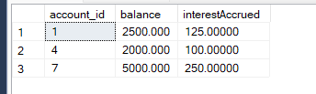

1. Write a SQL query to Identify accounts where the balance is less than a specified overdraft limit.

o/p

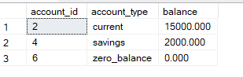

1. Write a SQL query to Find customers not living in a specific city.

o/p

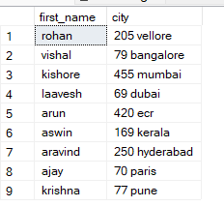

**TASK 3**

1. Write a SQL query to Find the average account balance for all customers.

O/P

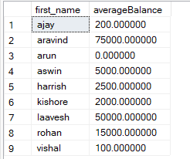

1. Write a SQL query to Retrieve the top 10 highest account balances.

o/p

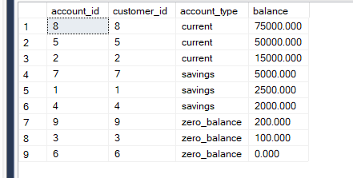

1. Write a SQL query to Calculate Total Deposits for All Customers in specific date.

o/p

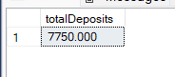

1. Write a SQL query to Find the Oldest and Newest Customers.

o/p

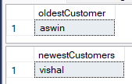

1. Write a SQL query to Retrieve transaction details along with the account type

o/p

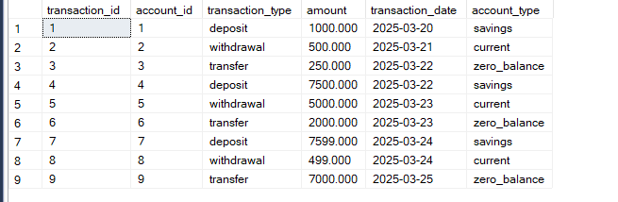

1. Write a SQL query to Get a list of customers along with their account details.

o/p

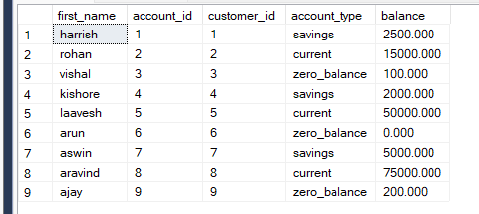

1. write a SQL query to Retrieve transaction details along with customer information for a specific account.

o/p



1. Write a SQL query to Identify customers who have more than one account

o/p



There is not customers with more than one account

1. Write a SQL query to Calculate the difference in transaction amounts between deposits and withdrawals

o/p

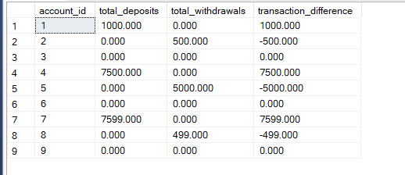

1. Write a SQL query to Calculate the average daily balance for each account over a specified period.

o/p

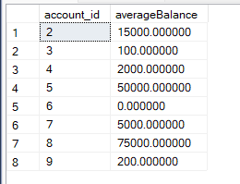

1. Calculate the total balance for each account type.

o/p

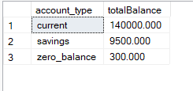

1. Identify accounts with the highest number of transactions order by descending order

o/p

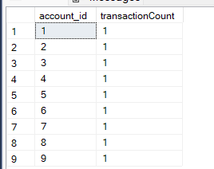

1. List customers with high aggregate account balances, along with their account types

o/p

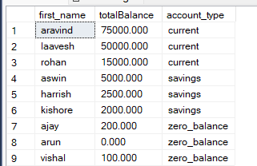

1. Identify and list duplicate transactions based on transaction amount, date, and account.

o/p

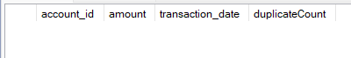

There is no duplicate transactions

**TASK4:**

1. Retrieve the customer(s) with the highest account balance

O/P

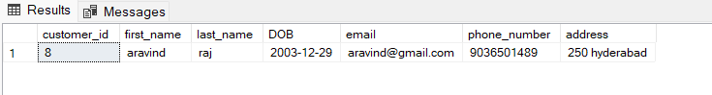

1. Calculate the average account balance for customers who have more than one account.

O/P

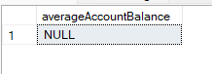

1. Retrieve accounts with transactions whose amounts exceed the average transaction amount.

o/p

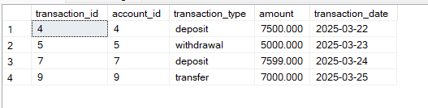

1. Identify customers who have no recorded transactions.

o/p

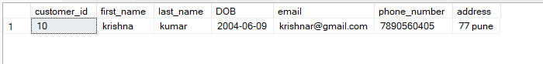

1. Calculate the total balance of accounts with no recorded transactions.

o/p

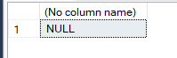

1. Retrieve transactions for accounts with the lowest balance

o/p

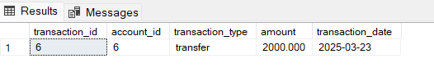

1. Identify customers who have accounts of multiple types.

o/p



No customer has multiple type of accounts

1. Calculate the percentage of each account type out of the total number of accounts

o/p

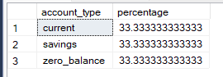

1. Retrieve all transactions for a customer with a given customer_id.

o/p

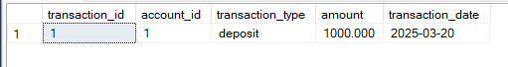

1. Calculate the total balance for each account type, including a subquery within the SELECT clause.

o/p

